**DSD LAB REPORT**

# LAB # 03



# Spring 2021

[**CSE-308L Digital System Design Lab**](https://classroom.google.com/u/0/c/MzA5OTAyNzE2MzM2)

Submitted by: **Hurair Mohammad**

Registration No.: **18PWCSE1657**

Class Section: **B**

“On my honor, as student of University of Engineering and Technology, I have neither given nor received unauthorized assistance on this academic work.”

Student Signature: ______________

Submitted to:

# Engr. Madiha Sher

Department of Computer Systems Engineering

University of Engineering and Technology, Peshawar

**OBJECTIVES:**

This lab will enable students to:

* Learn top down and bottom up design methodologies
* Use seven segment display available on the S3board
* Data flow level modeling

**TASK:**

**(Active Low):**

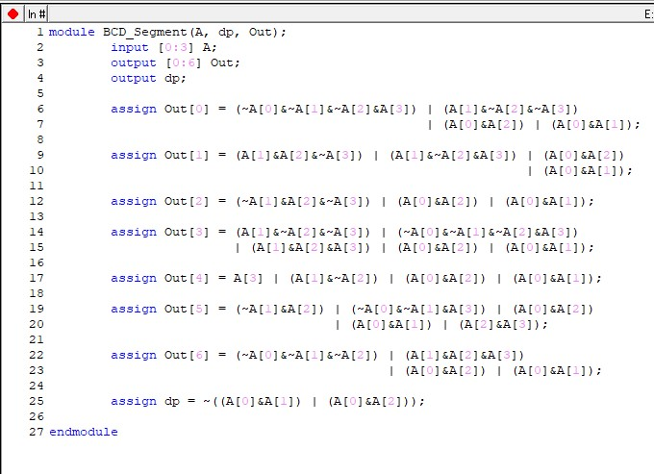

* A [0] = Most Significant bit
* A [3] = Least Significant bit

**TestBench:**

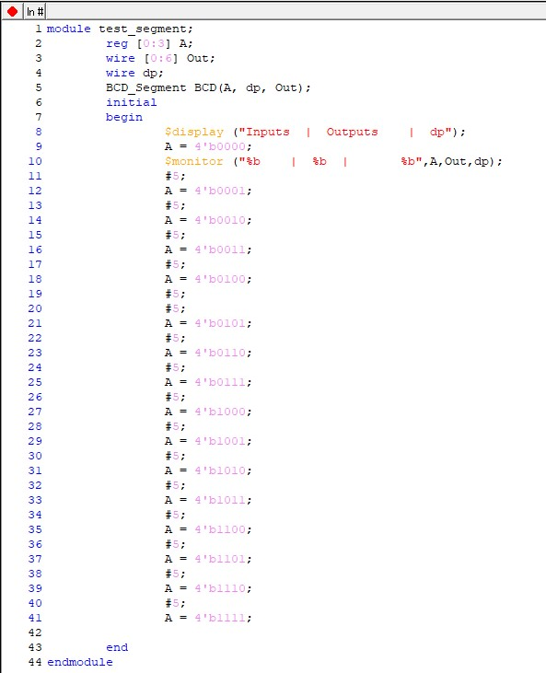

**OUTPUTS**

**Truth Table:**

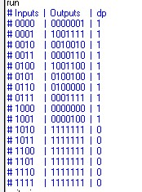

**Data Flow:**

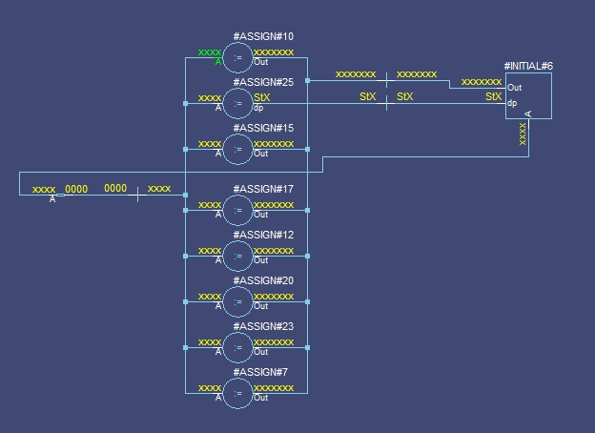

**Wave Form:**

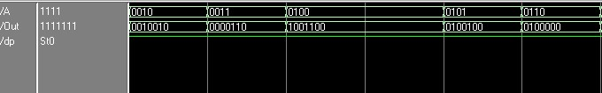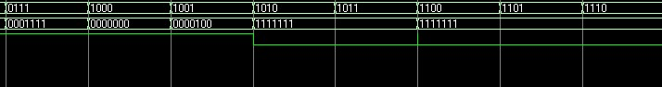

**CODE02 (Perform in Lab):**

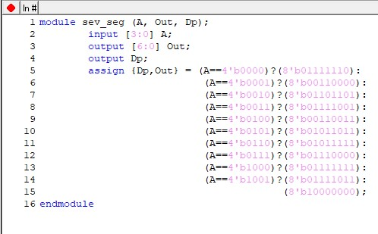

**TestBench:**

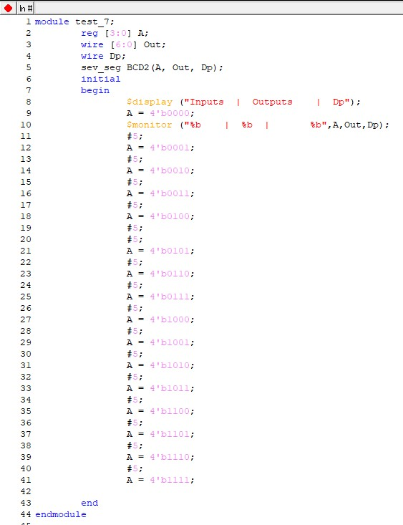

**OUTPUTS**

**Truth Table:**

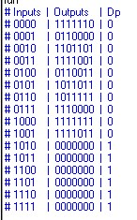

**Data Flow:**

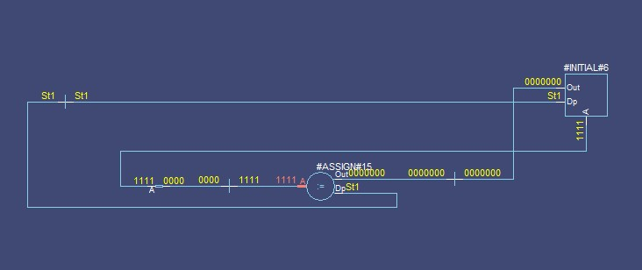

**Wave Form:**

